Epic for Nursing Students
Practice Exercise Packet
This document contains confidential and copyrighted information of Epic Systems Corporation.
Overview
During your classroom training, you completed three computer-based training modules where you had an introduction to the tasks that you’ll perform most often as a nursing student on Children’s inpatient units. When you’re working with your nurse instructor or preceptor, you’ll find that you need to:
- Access patient records
- Distinguish between Summary and Chart Review Activities
- View a list of active orders
- Document patient information utilizing Flowsheets
- Locate intake and output data
- View a list of all medications
- Review and document notes using the notes activity
Practice Makes Prepared
This exercise packet is designed to give you an opportunity to practice before logging into Epic in the live production environment. Our practice area is called the Epic Playground, and you’ll need to log in using the ID card that you received in the classroom. Work through the exercises, here, before staring your clinicals.

- Exercises are scenario based.
- When you’re posed with a question, it should prompt you to perform your next step in Epic.
- If you’re uncertain about what the next step should be, consult the Step-by-Step Guide in the back of this packet.
A Few Tips

Follow the instructions on the next page to access the Epic Playground.

Access the Epic Playground

From Workspace:
From your desktop screen or from within Clinical desktop, Click on Workspace, if accessing from home, go to https://workspace.childrens.com
Under the Catalog options, find the below icon and launch the Epic PLY App. You can also search for the app at the top.

From Learn Epic:

Go to learnepic.childrens.com to launch Learn Epic. click on the link to access Workspace. Under the Catalog options, search or find the below icon and launch the Epic PLY App.

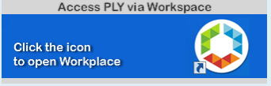

Log into the Playground with the User ID and password on the ID card provided during training. In this example, the system would recognize you as Sara Adrenal
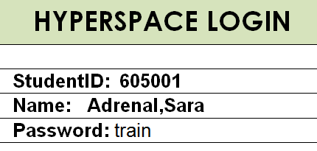
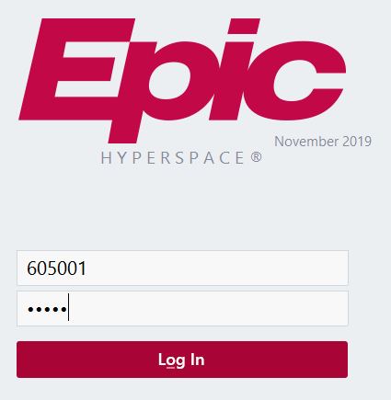

Enter the department name DAL B4, and click the OK button
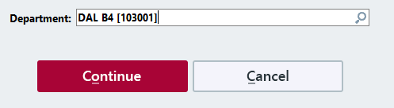

Access Patient Information
From the home workspace, find the patient on your ID card. Her first name is Ellie. Her last name will vary depending on which card you were given. Remember, you’re working on the inpatient unit, DAL B4 today

Step 1. How will you find the patient?
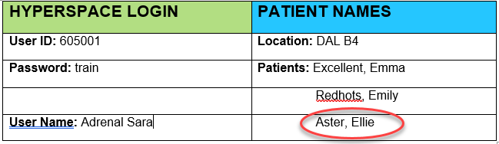

Chart Review

Chart review is a collection of all past encounters for your patient. These encounters are grouped by tab, and you can view any encounter that your patient has had with the hospital, outpatient clinics, or other departments at Children’s. You need to know about Ellie’s previous Emergency Department and Inpatient visits.

Step 2. Which tab will you click on to view all of Ellie’s encounters with Children’s?

Step 3. On what date did Ellie first visit the Emergency Department?

Step 4. What was the patient’s diagnosis for that visit? _____________________________________

Summary

Summary is where you’ll find information about your patient’s current visit at Children’s. It’s also where you’ll find many useful reports including PTA Meds, Vitals/Drips, and Care Plan. The report that you’ll use most often is the Nurse Kardex. This report shows a list of all active orders.

You’re about to start your shift, and you need to view a list of all active orders.

Step 5. How will you get to the Summary?

Step 6. Of all the reports in Summary, which will you choose to get to active orders?

Step 7. What is the first medication order on the Kardex? _____________________________________

If you’re not sure, answers for each step are in the back of this exercise package.

Document an Assessment

You’ve just assessed your patient and you need to document the assessment in Epic.

Step 8. What activity will you click on?

Step 9. Your instructor is Sidney Blackberry. What do you need to do before documenting in the activity?

Step 10. What tab will you document under?

Your patient’s neurological and cardiovascular assessments were normal, but the respiratory assessment was abnormal. You noticed that upper airway sounds were transmitted and her breathing was labored. She also had nasal flaring. Retractions were mild intercostal and chest movement was equal bilaterally.

Step 11. How do you document normal neurological and cardiovascular assessment?

Step 12. How do document the abnormalities for the respiratory assessment?

For breath sounds, Ellie’s LUL and RUL were coarse; LLL, RML, and RLL were diminished.

Step 13. Document for breath sounds.

The findings for the balance of Ellie’ s assessment are listed below.

Step 14. Continue documenting your assessment so that you update all of the information listed in the Assessment.

More Assessment Details
Respiratory (cont’d)  SpO2: 96  Pulse Ox Site: Left, ring finger  Cough Description: Strong  Cough Character: Productive  Sputum Amount: Small  Sputum Consistency: Thin  Sputum Color: Clear  Sputum How Obtained: Spontaneous | Gastrointestinal: X  Add GI Symptoms from the cascade window and click Add. Click OK  GI Symptoms: Loss of Appetite, Nausea  Abdominal Characteristics: Distended, Tender  Click the paper icon to add a comment that the tenderness located near the right abdominal incision.  Bowel Sounds (All Quadrants): Hypoactive
Genitourinary: WNL

If you’re not sure, answers for each step are in the back of this exercise package.

Integumentary: WNL

PIV group:  - Status: Infusing  - Infiltration Grade: 0  - Phlebitis Score: 0  - Dressing Assessment: Clean, Dry, Secured | 1st Wound group (Surgical Incision Other):  - Assessment: Pink  - Closure: Approximated  - Drainage Amount: Small  - Drainage Character: Thin  - Drainage Color: Serosanguinous  - Drainage Odor: No odor  - Dressing Status: Clean, dry, intact
2nd Wound group (Surgical Incision Mid Lower Abdomen):  - Assessment: Pink  - Closure: Approximated  - Drainage Amount: Small  - Drainage Character: Thin  - Drainage Color: Serosanguinous  - Drainage Odor: No odor  - Dressing Status: Clean, dry, intact | 3rd Wound group (Surgical Incision Right; Lower Abdomen):  - Assessment: Reddened  - Closure: Approximated  - Drainage Amount: Moderate  - Drainage Character: Thin  - Drainage Color: Serosanguinous  - Drainage Odor: No odor  - Dressing Status: Clean, dry, intact

Musculoskeletal: WNL | EENMT (WNL): WNL
Pain Assessment( 0-10 Pain Scale): Sedation Level: Awake and Alert, Pain Score: 0

You’ve now completed your head-to-toe assessment.
Step 15. How do you save your documentation?

Document Daily Cares
Now, you need to document Daily Cares for Ellie.
Step 16. Click on the correct flowsheet for documenting daily cares.
You completed Daily Cares at 0845.
Step 17. What button do you click to back chart, and how will you enter an accurate time?
At 0845, Ellie had a shower while you changed her linens. She walked to the shower with some minimal assistance from you.
Step 18. What will you chart for your 0845 Daily Cares?

If you’re not sure, answers for each step are in the back of this exercise package.
Look at the Neonatal Cares group in the flow sheet and find the row named ‘Is the Patient an Infant?’ This is a cascading row. Based on your response to this row, you may be prompted to add rows to the flowsheet, or rows may be automatically added for you. Ellie is not an infant, but for the sake of exploration, let’s document as if she were.
Step 19. Document ‘yes’ in response to ‘Is the Patient an Infant?’ row. What information do you need to document for infants?
You’ve completed your documentation for Ellie’s Daily Cares.
Step 20. How will you save your documentation?
______________________________________________________________

Document Intake & Output Data

You have another patient on your class ID Card.

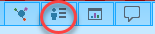
Step 21. Look at the card and open the chart for your Emily patient. Go back to the home workspace to do this.

Emily had breakfast at 0900. She ate an apple and an omelet. She also drank one cup of water. At 1000 hours, she urinated, but didn’t do so in the hat, so you don’t have a measurement.

Step 22. What activity will you click on to document Emily’s intake and output?

Step 23. What tab will you select inside the activity?

Step 24. How will you record Emily’s breakfast and voiding?

View a List of All Medications

It’s 10:00 p.m. and you need to view Ellie’s medications for the shift starting at 7:00 a.m. tomorrow (Be sure to switch patients).

Step 25. How will you get to the full list of Ellie’s medications?

You need to get to the formulary for the medication due at 1500.

Step 26. What is the name of the medication?

Step 27. How will you get to the formulary for this medication?

Write a Note

Emily’s parents have a concern about the care being provided. You need to document the concern but couldn’t find a place to do this in Flowsheets. Your instructor’s name is Sidney Blackberry.
Step 28. What must you do before writing a note?
Step 29. What activity will you click on to document your note?
Step 30. What button will you select to add a note?
Step 31. What note type will you use?
Step 32. How will you document the note and confirm that you authored the note?

Continue to the next page for a step-by-step guide.

Step-by-Step Guide
Access Patient Information

Step 1. Open your patient’s chart. |  | Follow this path to find your patient: System List > Units Folder > DAL B4 > Click on your patient’s name.
Chart Review
Step 2. In the Chart Review Activity, which tab will you choose to view all of Ellie’s encounters? |  | Click on the Chart Review activity , then click on the Encounters tab.
Step 3. On what date did your patient first visit the Emergency Department? |  | Your patient’s first visit to the ED should have been roughly 5 months ago.
Step 4. What was the patient’s diagnosis for that visit? |  | The diagnosis was DM type 1 (diabetes mellitus, type 1) [250.01]
Summary
Step 5. What activity will you click on to view a list of all active orders? |  | The Summary activity.  Alternately, you can access the Summary Window to get to reports.
Step 6. Of all the reports in the Summary, which will you choose to get to active orders? |  | Click on the Nurse Kardex report.
Step 7. What is the first medication order on the Kardex? |  | Your patient has an order for ampicillin RTA infusion 1160 mg
Document an Assessment
Step 8. What activity will you click on? | Go to the Flowsheets activity. Remember to enter Instructor Blackberry’s name in the cosignature box.
Step 10. What tab will you document in? | Click on the Gen Peds - Assessment flowsheet button near the top of the screen.
Step 11. How do you document normal neurological and cardiovascular assessment? |  | Use the Details window on the right hand side of your screen to document the following: Remember to Add Column for current time.  - Neurological: WNL  - Cardiovascular: WNL
Step 12. How do you document the abnormalities for the respiratory assessment? |  | - Select Upper Airway Noises and click the Add Button. Repeat for Work of Breathing, then click OK  - In the Upper Airway Noises Row, select Transmitted Upper Airway Sounds from the Details window, then click Enter or right click to stick your selection.  - In the Work of Breathing Row, select Labored and Nasal flaring from the Details window, then click Enter or right click to stick your selection.  - Skip the Retired-Work of Breathing.  - In the Retractions Row, select Mild Intercostal  - In Chest movement, select equal bilaterally
Step 13. Document for breath sounds. |  | In the Breath Sounds group, select:  - LUL Breath Sounds: Coarse  - LLL Breath Sounds: Diminished  - RUL Breath Sounds: Coarse  - RML Breath Sounds: Diminished  - RLL Breath Sounds: Diminished
Step 14. Continue documenting your assessment so that you update all of the information. |  | Use the information in the assessment details chart (pgs. 5 & 6) to fill in the flowsheet. Move down the flowsheet section by section.  Remember to Add Column for current time to see the available selections in the details.
Step 15. How do you save your documentation? |  | 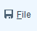  Click the File button to save your work

Step-by-Step Guide

Document Daily Cares
Step 16. | Click the Daily Cares flowsheet button on the toolbar at the top of the screen  Notice this flowsheet has quite a few groups beginning with Personal Cares and ending with Activity. You may need to use the scroll bar to see the entirety of this flowsheet’s table of contents.
Step 17. What button do you click to back chart, and how will you enter an accurate time? | Click Insert Column, and change the time to 0845, then click Accept.
Step 18. What will you chart for your 0845 Daily Cares? | Chart the following  - Bath: Complete  - Procedure Tolerance: Cooperative  - Linens Changed: Done  - Activity: Up to Bathroom  - Level of Assistance: Minimal assistance
Step 19. Find the Neonatal Cares group in the flow sheet and find the row named Is the Patient An Infant? | Document yes to explore the information you will need to document for infants. In the details window, you would select the appropriate information to describe diaper care.
Step 20. How will you save your documentation? | Click the File button.
Document Intake and Output
Step 21. Look at the card and open the chart for your Emily patient. | On the Dal B4 unit, look for the Emily patient on your Class ID Card and open her chart by double clicking on the row with her information.
Step 22. What activity will you click on to document Ellie’s intake and output? | Click on the Flowsheets activity, and enter your instructor’s last name (Blackberry) in the cosignature box. Your instructor’s name is Sidney Blackberry.
Step 23. What tab will you select inside the activity? | Click on the I/O Flowsheet
Step 24. How will you record Emily’s breakfast and voiding? | Document the breakfast in the top section of the I/O flowsheet in mm and voiding in the bottom section of the I/O flowsheet. Since you don’t have a measurement for the voiding, enter 1 in Void Count.
View a List of All Medications
Step 25. How will you get to the full list of Emily’s medications? | Click on the MAR activity, and then go to the ALL tab .
Step 26. What is the name of the medication due at 8:00 a.m. and 12:00 p.m.? | cefOXitin RTA infusion 1,900 mg
Step 27. How will you get to the formulary for this medication? | Make sure that the MAR is in the “Show All Details” view, find the medication, and click on the Lexicomp link in the reference section.
Write a Note
Step 28. What must you do before writing a note? | Notify your instructor or preceptor that you need to write a note so that s/he is aware of the need to sign the note. By talking with your instructor, you also confirm that the note is warranted and that there is no alternative place for documenting the information.
Step 29. What activity will you click on to document your note? | Click on the Notes Activity on the left side of the screen.
Step 30. What button will you select to add a note? | Click on the New Note button in the Notes activity.
Step 31. What note type will you use? | Select Progress Note for the note type.
Step 32. How will you document the note and confirm that you authored the note? | Type your note and click on the sign button.

