Epic Playground (PLY) & Exam Training Accounts
Remote Login Tip Sheet

Overview

This document provides an overview of how to access the Epic Playground (Ply) & Exam apps remotely or using a personal computer. It also provides the training account logins necessary to open the apps which should be used in conjunction with the Playground Training Logins pertaining to your area/role.

- Install the Citrix workspace application by reviewing the step by step instructional video here. With this application installed on the computer, users will be able to use the children’s Citrix site to access both PLY and Exam apps remotely.

- Open a web browser and enter “citrix workspace windows download.” (Note: If using a Mac enter “citrix workspace mac download”).

- Select the first result as it is the correct one - Citrix Workspace app 2008.

- Click Download Citrix workspace app for windows/mac and save to the desktop.

- Launch application once downloaded.

- Click Start and accept the disclaimer by selecting the checkbox. Click Next followed by Install. Once installed, click Finish.

- Go to https://citrix.childrens.com/vpn/index.html and remove any populated login information.

- Log into the Citrix Application Portal using any of the below Usernames (EpicAG#). The password for all logins is “Epictraining2020” (please adhere to all capital and lowercase letters).

Training Login Usernames | Password
EpicAG1 – EpicAG50 | Epictraining2020

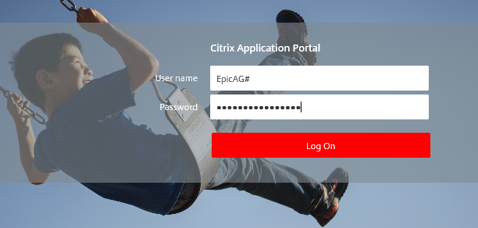

- Review the Catalog options and select the PLY app to open. Note: There are only two apps available while logged in as this user.

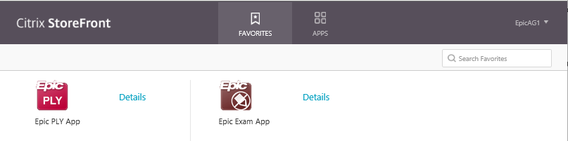

- Log into PLY using the training login information pertaining to your area/role as provided below. The password for all logins is “train” (all lowercase).

See assigned logins ( Classroom Sheet Patient Assignment Spreadsheet )

